Lab 13 Report Template

1. **Lab exercises**

**1.1 Lab1.E1**

**1.1.1 describe how you think to solve the problem.**

I firstly to contribute a python class named Stack and write relevant methods in this class. Then I write a method to transfer the infix expression to postfix, which use tow stack to store characters. Also, there is a method to check the parentheses matching of the infix expression. The last step, I written a method to calculate the result of the postfix expression.

**3.1.2 main code of program, include annotations.**

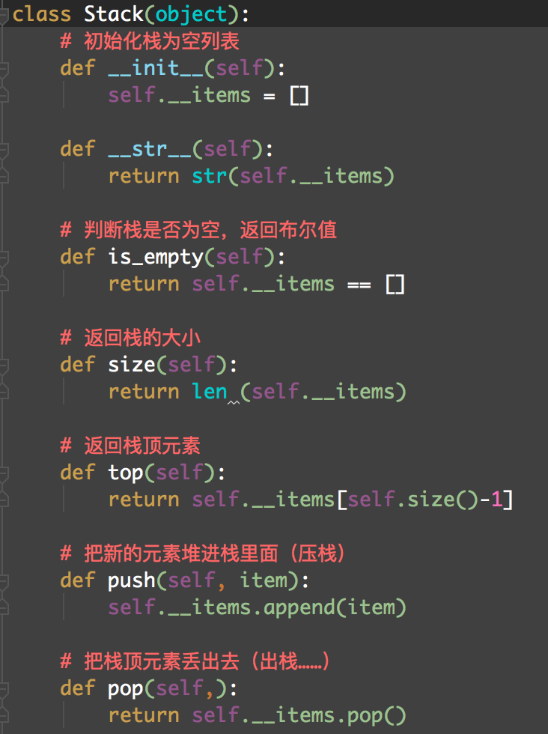The main algorithm could be a function, with input and output arguments, and the arguments should be clearly explained.

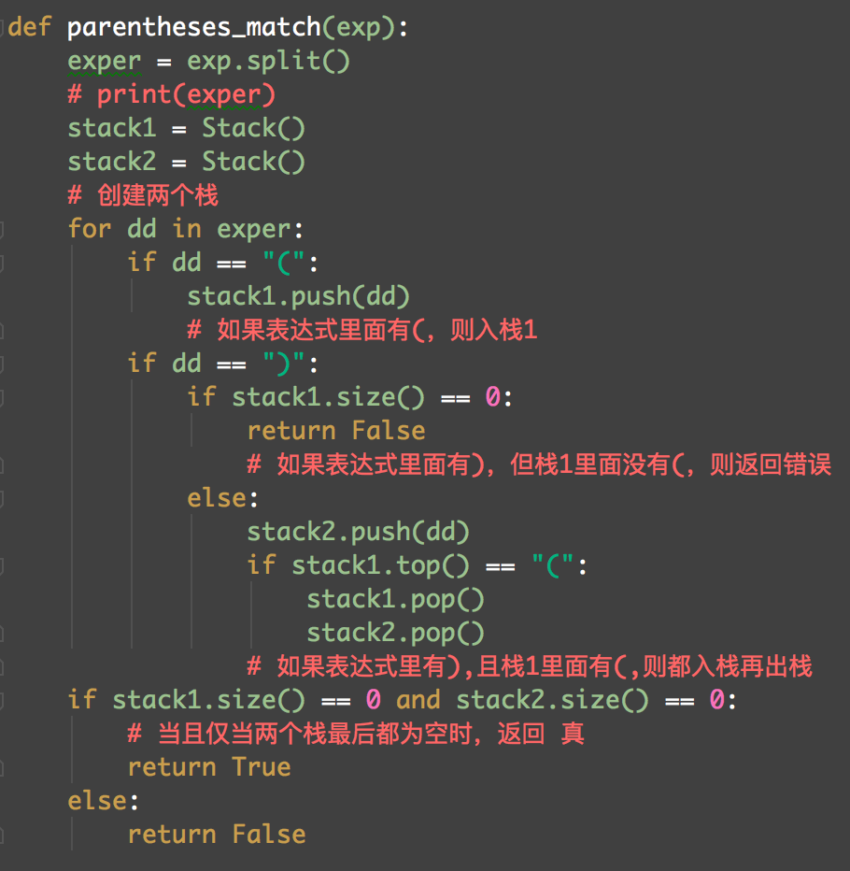

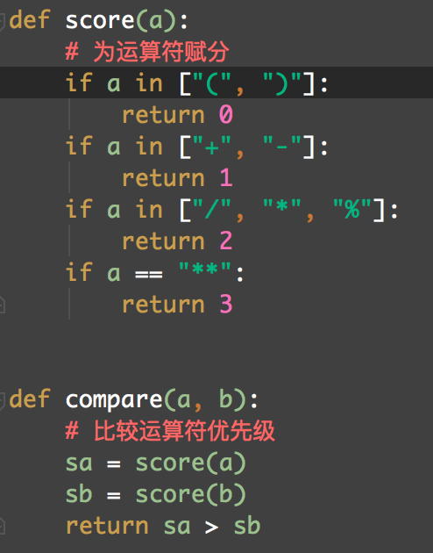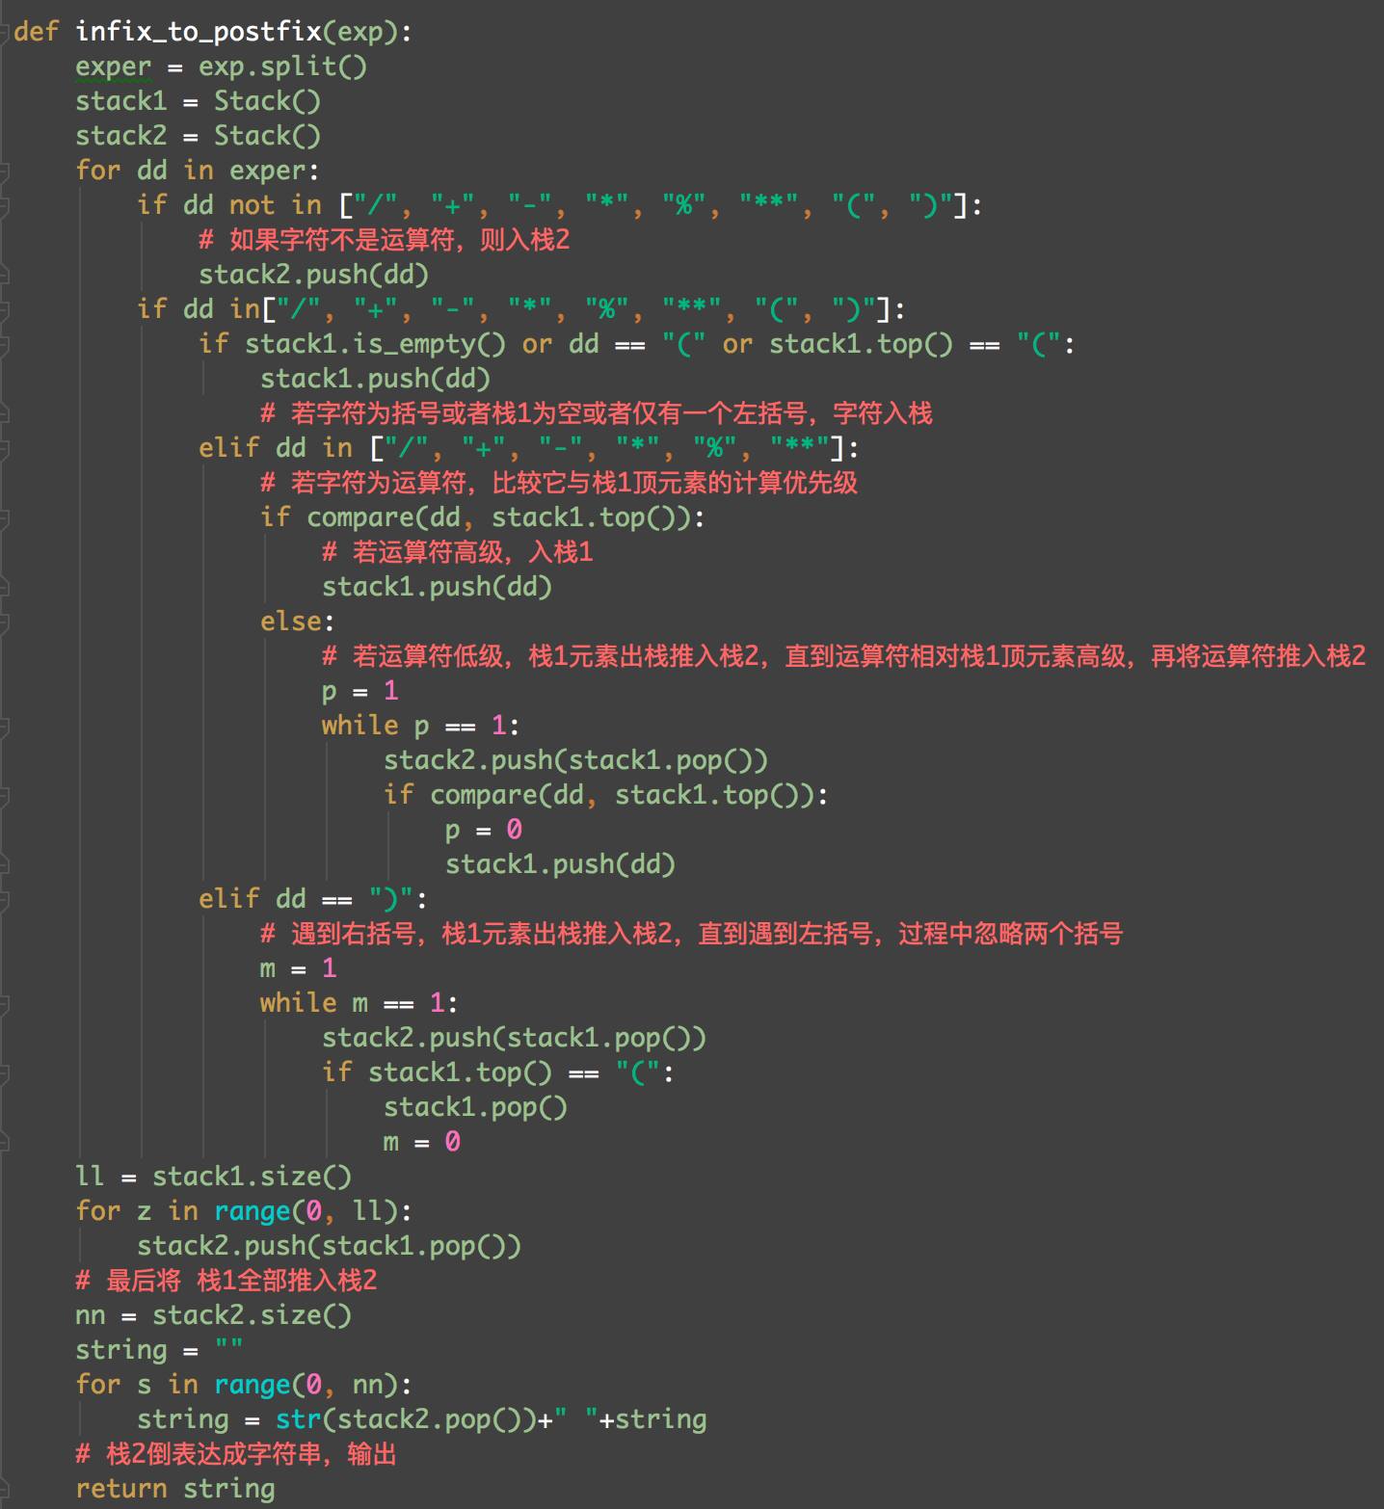

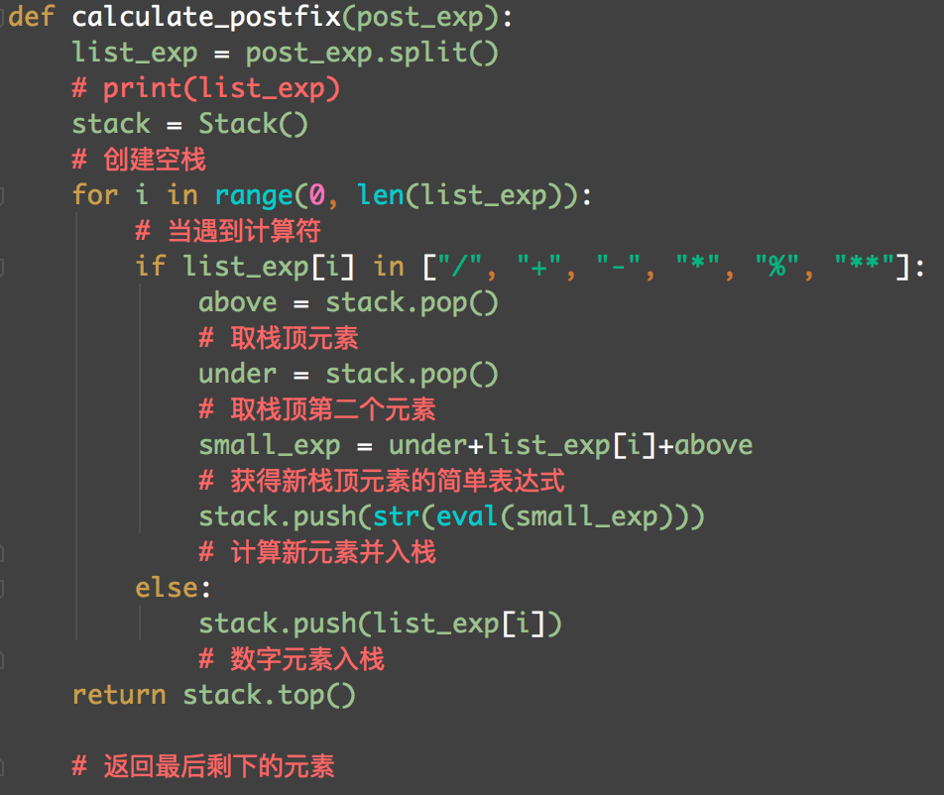

**3.1.2 show some screenshot of the running results with test data.**

Test:

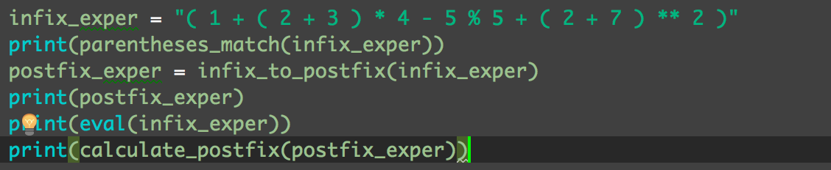

Output:

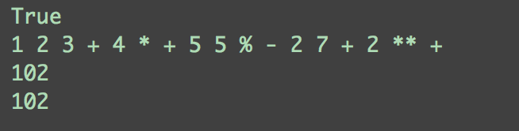

The eval method gives the correct result of the index expression.

**3.2 Lab2.E2**

For some simple index expression like “ 1 + 2 * 3 ”, I can split the expression into 2 queues to store the number and the operational character alone to change it into the postfix. However, I cannot finish the problems with parentheses. So I think that the queue is unfit for the task to transfer the infix expression into postfit.